Cyber-Physical Attack Detection in Smart Grids Using Graph Signal Processing
Aniket Rajak
Department of Information Technology
Indian Institute of Information Technology
Sonepat, India
aniketrajak849@gmail.com
Rushil Jain
Department of Information Technology
Indian Institute of Information Technology
Sonepat, India
rushiljain69@gmail.com

Abstract—False data injection attacks (FDIA) are a major cyber-physical threat to smart grids because they can manipulate control decisions while bypassing conventional residual-based bad data detection. This report presents an empirical and theoretical comparison of three detection methods: residual bad data detection (BDD), nodewise statistical Z-score detection, and graph signal processing (GSP)-based high-frequency anomaly detection. A reproducible Python simulation was implemented on a connected 30-bus graph with a linear measurement model and two attack classes: random FDIA and stealth FDIA designed in the measurement model subspace. Experimental results show that residual BDD detects random attacks well but fails on stealth attacks, while Z-score detection underperforms in both scenarios. GSP achieves the best overall attack detection with strong stealth-attack recall and low false positive rate. The findings support the use of topology-aware graph spectral methods for smart-grid cyber-physical anomaly detection.
Keywords— Smart Grid, False Data Injection Attack, Graph Signal Processing, Cyber-Physical Security, Anomaly Detection

Introduction
Smart grids combine electrical infrastructure with communication and computation layers, enabling real-time monitoring and automated control. This cyber-physical coupling improves efficiency but increases attack surface. Among known threats, FDIA is particularly dangerous because the attacker can manipulate measurements and influence state estimation and downstream decisions.
A key challenge is that many practical monitoring pipelines rely on residual checks from state estimation. Prior literature shows that coordinated attacks can be crafted to evade these checks. This motivates structure-aware approaches that exploit physical network topology in addition to raw measurement consistency.
This report evaluates whether GSP can improve FDIA detection, especially for stealth attacks that evade classical residual-based checks.

background and context
Smart grids integrate power systems with communication networks, improving efficiency but increasing exposure to cyber-physical attacks. Among these, False Data Injection Attacks (FDIA) are critical, as they can manipulate measurements while bypassing traditional residual-based detection.
Conventional methods such as Bad Data Detection (BDD) rely on measurement inconsistency and fail against coordinated (stealth) attacks. While machine learning methods improve detection, they require labelled data and may lack generalization.
Graph Signal Processing (GSP) provides a topology-aware framework by analysing signals over the grid structure. This enables detection of anomalies that appear as irregularities in the graph spectral domain.

Related work
The foundational FDIA vulnerability is established in the smart-grid state-estimation context by Liu, Ning, and Reiter, who show attack vectors that can bypass traditional bad-data detection while causing arbitrary state errors.
Classical state estimation and bad-data detection formulations are detailed in standard power-system estimation literature and comparative BDD studies. Later work introduced sparse-optimization and machine-learning based detectors, and several deep-learning approaches improved detection rates under certain data assumptions.
In parallel, GSP developed a formal framework for signals defined on irregular domains (graphs), including graph Fourier analysis and graph spectral filtering. Recent power-system work has started applying GSP concepts for bad-data/anomaly detection.

System and threat model

Measurement Model
The simulation uses a linearized measurement model:
$$z=Hx+e$$
where z is the measurement vector, H is the measurement matrix, x is the state vector (bus-level state signal), and e is Gaussian noise.

Threat Model
The attacker can manipulate measurement data and has knowledge of the system model $H$. The goal is to alter state estimation while remaining undetected. The system assumes Gaussian noise and fixed grid topology.

Attack Model
Two FDIA classes were used:
- Random Attack: sparse, high-magnitude perturbations on measurements.
- Stealth Attack: model-consistent attack with a = Hc, giving:
$$z^{'}=z+Hc$$
For this attack type, residual-based detection is theoretically weak because the attack lies in the measurement model subspace.

Graph Model and GSP Score
The grid is represented as a graph G = (V, E) with Laplacian $L=D-A$. The estimated state signal $\hat{x}$ is projected onto graph spectral components. The detector score is defined as the high-frequency energy ratio:
$${score}_{gsp}= \frac{{\left\|U_{HF}^{T}\hat{x}\right\|}_{2}^{2}}{{\left\|U^{T}\hat{x}\right\|}_{2}^{2}}$$
where U is the Laplacian eigenvector matrix and $U_{HF}$ selects high-frequency eigenmodes.

Compared Detection methods

Residual BDD
- Residual score:
$${score}_{res}= \frac{{\left\|z-H\hat{x}\right\|}_{2}}{\sqrt{m}}$$
- Decision: attack if ${score}_{res }$exceeds a normal-data threshold.

Nodewise Z-score Baseline
- Using training normal data mean mu and std sigma, the score is:
$${score}_{z}= \max_{i}\left|\frac{{\hat{x}}_{i- }μ_{i}}{σ_{i}}\right|$$
- Decision: attack if ${score}_{z}$ exceeds a normal-data threshold.

GSP high-frequency Detector (proposed)
- Decision: attack if ${score}_{gsp}$ exceeds a normal-data threshold.

Setup and implementation

Workflow Overview
The proposed detection pipeline follows a structured sequence:
- Generate a connected graph representing the power grid topology.
- Construct the graph Laplacian matrix $L=D-A$.
- Generate smooth graph signals representing normal system states.
- Apply measurement model $z=Hx+e$.
- Inject attack vectors (random or stealth).
- Estimate system state using least squares:
$$\hat{x}=(H^{T}H)^{-1}H^{T}z$$
- Compute detection scores:
- Residual BDD
- Nodewise Z-score
- GSP high-frequency energy ratio
- Apply threshold-based classification.

Implementation Notes
The system is implemented in Python using:
- networkx for graph generation
- numpy and scipy for numerical computation
- matplotlib for visualization
A connected random geometric graph with 30 buses and 60 measurements is generated. The measurement matrix $H$is randomly initialized and ensured to be full rank. Graph spectral decomposition is performed using eigenvalue decomposition of the Laplacian.
High-frequency components are identified by selecting the upper portion of eigenmodes, and the GSP score is computed as the ratio of high-frequency energy to total signal energy.
Thresholds are determined using the 99.5th percentile of validation data (aux_stats.json) to maintain low false positive rates.

Experimental Setup
- Graph: connected 30-bus random geometric graph.
- Measurements: 60 channels.
- Noise: Gaussian, std = 0.05.
- Data splits:
- Train normal: 1400
- Validation normal: 400
- Test normal: 800
- Test random attack: 500
- Test stealth attack: 500
- Thresholding: 99.5th percentile of validation-normal score for each detector.
Outputs were generated by the script at run_fdia_gsp_experiment.py

Results

Practical Comparison (measured performance)
Method | Scenario | Recall | FPR | F1 | AUC
Residual BDD | Overall | 0.504 | 0.0137 | 0.665 | 0.749
Residual BDD | Random Attack | 1.000 | 0.0137 | 0.989 | 1.000
Residual BDD | Stealth Attack | 0.008 | 0.0137 | 0.016 | 0.498
Z-score Nodewise | Overall | 0.002 | 0.0087 | 0.004 | 0.509
Z-score Nodewise | Random Attack | 0.004 | 0.0087 | 0.008 | 0.511
Z-score Nodewise | Stealth Attack | 0.000 | 0.0087 | 0.000 | 0.506
GSP High-Frequency | Overall | 0.880 | 0.0025 | 0.935 | 0.989
GSP High-Frequency | Random Attack | 0.810 | 0.0025 | 0.893 | 0.981
GSP High-Frequency | Stealth Attack | 0.950 | 0.0025 | 0.972 | 0.997
Performance is evaluated using recall, false positive rate (FPR), F1-score, and AUC.

Key empirical evidence for stealth vulnerability
Mean residual score by class:
- Normal: 0.03499
- Random attack: 0.70810
- Stealth attack: 0.03492
This directly confirms the stealth behavior: stealth attack residual is nearly indistinguishable from normal, while random attack residual is large.

Figures
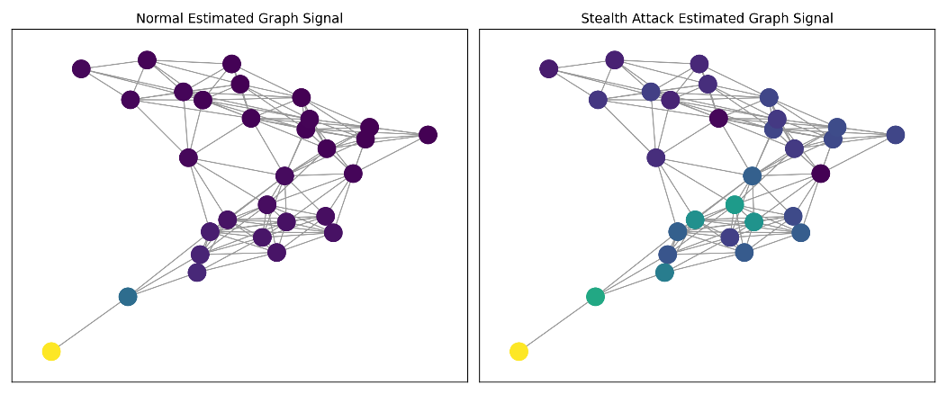
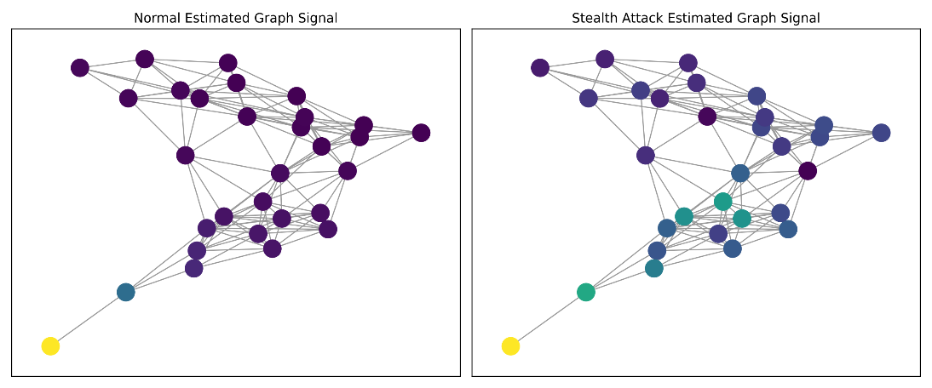
- Graph Signal Example

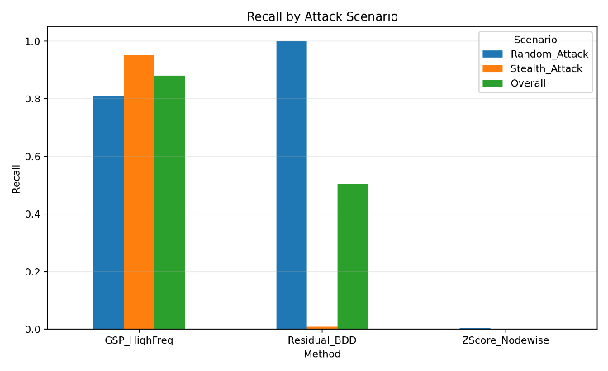
- Recall By Scenario

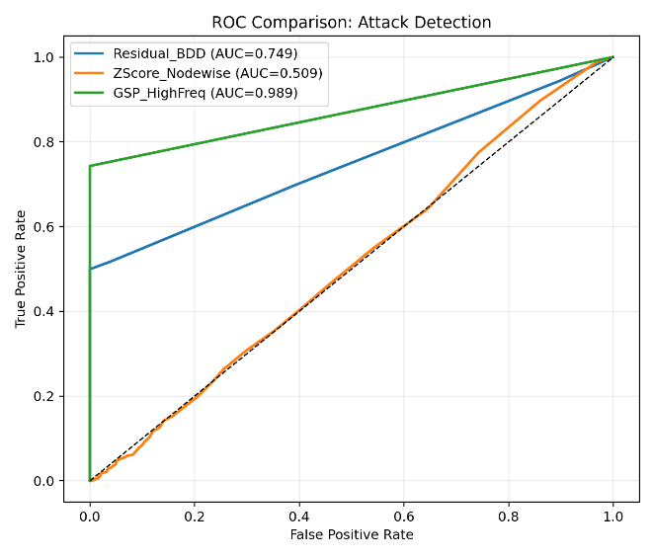
- ROC Comparison
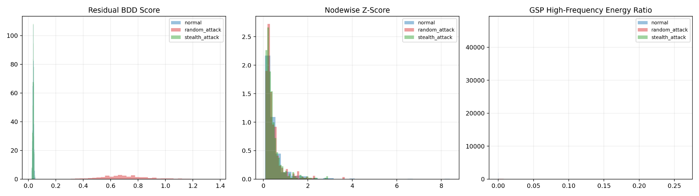
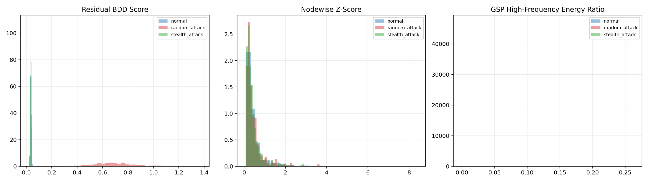
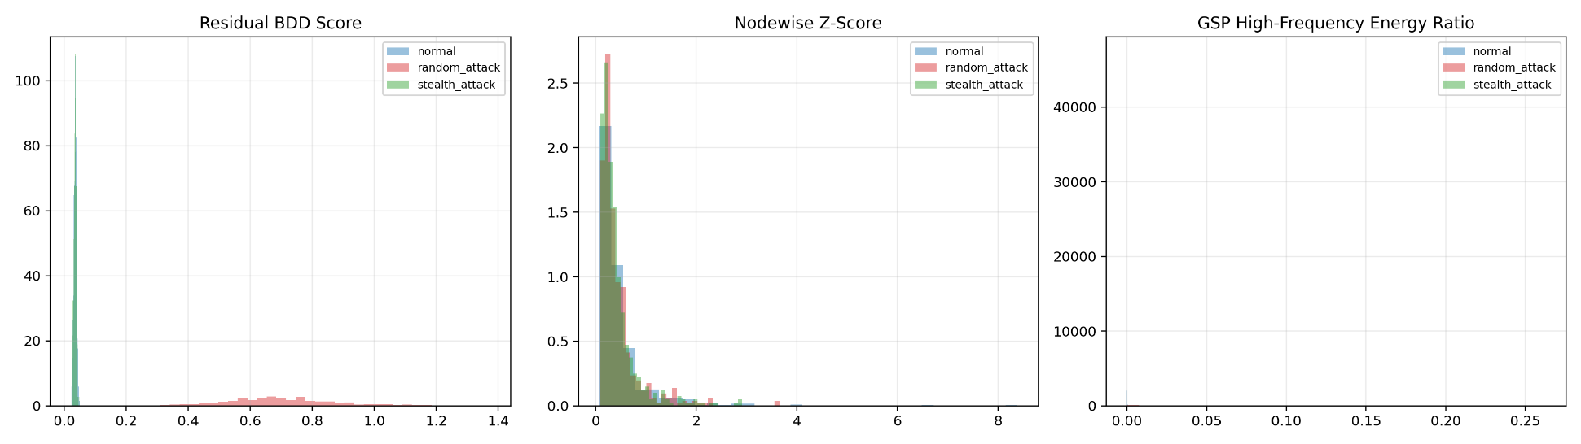
- Score Distributions

State estimation is performed using least-squares, and detection scores are computed using residual, Z-score, and GSP-based high-frequency energy metrics.
As shown in Fig. 2 and Fig. 3, GSP significantly outperforms baseline methods, particularly under stealth attack conditions.

Analysis and security discussion

Theoretical explanation

Residual BDD blind spot:
  - If attack vector is a = Hc, then $z^{'}$ = z + Hc remains consistent with model structure.
  - The estimator absorbs attack as state shift c, keeping residual nearly unchanged.

Nodewise magnitude blind spot:
  - Coordinated attacks can keep per-node deviations small and avoid pointwise thresholds.

GSP advantage:
  - Even small coordinated perturbations can inject graph-high-frequency content (non-smooth behavior across connected buses), which GSP explicitly measures.

Practical evidence from this run
- Residual BDD achieved near-perfect random attack recall but almost zero stealth recall.
- Z-score method remained near-random performance.
- GSP achieved strong detection in both random and stealth scenarios, with the best AUC and lowest FPR.

Security Discussion
Residual BDD performs well for random attacks but fails for stealth attacks, as residual values remain similar to normal data. Z-score methods also underperform due to lack of structural awareness.
The GSP method exploits graph topology to detect high-frequency irregularities, enabling effective detection of both attack types. This shows that topology-aware methods are more robust against coordinated attacks.

Limitations and future work

Limitations
- The study uses a synthetic random geometric graph, which may not fully capture real-world grid topology.
- The measurement model is linear and does not account for nonlinear AC power flow dynamics.
- The attacker is assumed to have knowledge of the system model, which may not always hold in practice.
- Detection is based on static snapshots and does not incorporate temporal dynamics.
- Threshold selection is based on validation data and may require tuning for different systems.

Future Works
  - Extend the approach to real IEEE benchmark systems (e.g., IEEE 14-bus, 118-bus).
  - Incorporate temporal models such as RNNs or Kalman filtering.
  - Develop adaptive thresholding mechanisms.
  - Combine GSP with machine learning models for hybrid detection.
  - Evaluate robustness under partial observability and missing data.

Conclusion
This study demonstrates that topology-aware graph spectral detection can substantially improve FDIA detection in smart grids, especially against stealth attacks that bypass residual-based checks. In this experiment, GSP provided the best tradeoff between recall and false alarms and showed a clear advantage in stealth attack detection.

reproducibility notes
Run Script: run_fdia_gsp_experiments.py
Main Outputs:
  - results/metrics_summary.csv
  - results/test_scores.csv
  - results/aux_stats.json

References
[1] Y. Liu, P. Ning, and M. K. Reiter, "False data injection attacks against state estimation in electric power grids," ACM Transactions on Information and System Security, vol. 14, no. 1, 2011, doi: 10.1145/1952982.1952995.
[2] A. Abur and A. Gomez-Exposito, Power System State Estimation. CRC Press, 2004, doi: 10.1201/9780203913673.
[3] O. Kosut, L. Jia, R. J. Thomas, and L. Tong, "Malicious data attacks on the smart grid," IEEE Transactions on Smart Grid, vol. 2, no. 4, pp. 645-658, 2011, doi: 10.1109/TSG.2011.2163807.
[4] G. Liang, J. Zhao, F. Luo, S. R. Weller, and Z. Y. Dong, "A review of false data injection attacks against modern power systems," IEEE Transactions on Smart Grid, vol. 8, no. 4, pp. 1630-1638, 2017, doi: 10.1109/TSG.2015.2495133.
[5] L. Liu, M. Esmalifalak, Q. Ding, V. A. Emesih, and Z. Han, "Detecting false data injection attacks on power grid by sparse optimization," IEEE Transactions on Smart Grid, vol. 5, no. 2, pp. 612-621, 2014, doi: 10.1109/TSG.2013.2284438.
[6] M. Esmalifalak, L. Liu, N. Nguyen, R. Zheng, and Z. Han, "Detecting stealthy false data injection using machine learning in smart grid," IEEE Systems Journal, vol. 11, no. 3, pp. 1644-1652, 2017, doi: 10.1109/JSYST.2014.2341597.
[7] Y. He, G. J. Mendis, and J. Wei, "Real-time detection of false data injection attacks in smart grid: A deep learning-based intelligent mechanism," IEEE Transactions on Smart Grid, vol. 8, no. 5, pp. 2505-2516, 2017, doi: 10.1109/TSG.2017.2703842.
[8] D. I. Shuman, S. K. Narang, P. Frossard, A. Ortega, and P. Vandergheynst, "The emerging field of signal processing on graphs," IEEE Signal Processing Magazine, vol. 30, no. 3, pp. 83-98, 2013, doi: 10.1109/MSP.2012.2235192.
[9] A. Sandryhaila and J. M. F. Moura, "Discrete signal processing on graphs," IEEE Transactions on Signal Processing, vol. 61, no. 7, pp. 1644-1656, 2013, doi: 10.1109/TSP.2013.2238935.
[10] A. Sandryhaila and J. M. F. Moura, "Discrete signal processing on graphs: Frequency analysis," IEEE Transactions on Signal Processing, vol. 62, no. 12, pp. 3042-3054, 2014, doi: 10.1109/TSP.2014.2321121.
[11] O. Anderson and N. Yu, "Distribution system bad data detection using graph signal processing," in 2021 IEEE Power and Energy Society General Meeting, 2021, doi: 10.1109/PESGM46819.2021.9638014.
[12] NetworkX Developers, "NetworkX," GitHub repository. [Online]. Available: https://github.com/networkx/networkx
[13] NumPy Developers, "NumPy," GitHub repository. [Online]. Available: https://github.com/numpy/numpy
[14] R. Jain and A. Rajak, "FDIA Detection using Graph Signal Processing," GitHub repository, 2026. [Online]. Available: https://github.com/your-repo-link

